**Project**

**Design**

**Phase-II**

**Data**

**Flow**

**Diagram**

**& User**

**Stories**

**Date**

28

October

2022

**Team**

**ID**

PNT2022TMID22731

**Project**

**Name**

Web

phishing

Detection

**Maximum**

**Marks**

4

Marks

**Data**

**Flow**

**Diagrams:**

A

Data

Flow

Diagram

DFD

)

(

is

a

traditional

visual

representation

of

the information

flows

within

a

system.

A

neat

and

clear

DFD

can

depict

the right

amount of the

system requirement graphically. It shows how data enters and leaves the system, what changes the information, and where data is

stored.

**DFD Level 0:**

**Example**

:

(

Simplified

)

FLOW

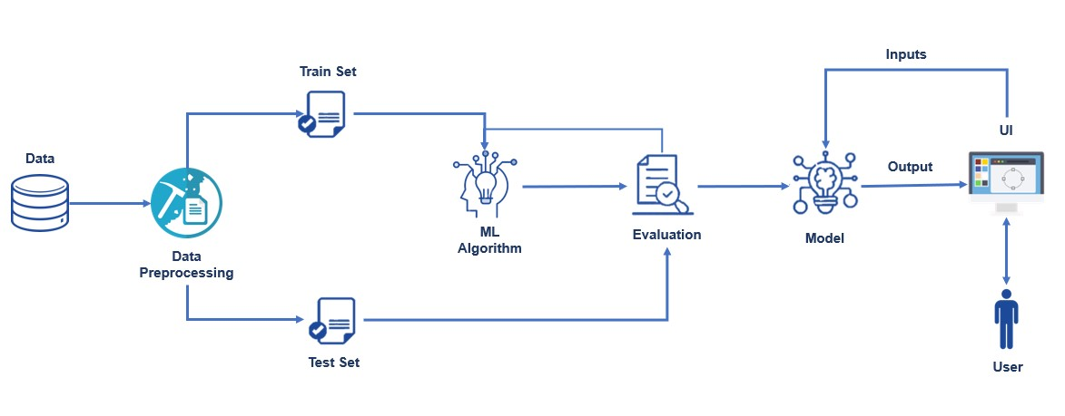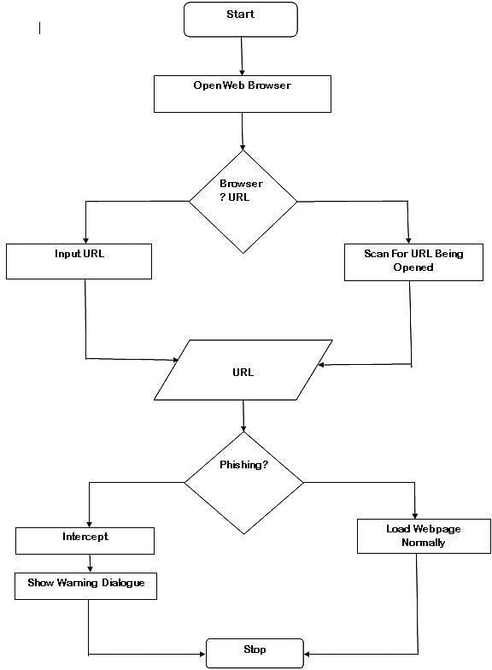

|  |  |  |  |  |  |  |  |  |  |  |  |  |  |  |  |  |  |  |  |  |  |  |  |  |  |  |  |  |  |  |  |  |  |  |  |  |  |  |  |  |  |  |  |  |  |  |  |  |  |  |  |  |  |  |  |  |  |  |  |  |  |  |  |  |  |  |  |  |  |  |  |  |  |  |  |  |  |
| --- | --- | --- | --- | --- | --- | --- | --- | --- | --- | --- | --- | --- | --- | --- | --- | --- | --- | --- | --- | --- | --- | --- | --- | --- | --- | --- | --- | --- | --- | --- | --- | --- | --- | --- | --- | --- | --- | --- | --- | --- | --- | --- | --- | --- | --- | --- | --- | --- | --- | --- | --- | --- | --- | --- | --- | --- | --- | --- | --- | --- | --- | --- | --- | --- | --- | --- | --- | --- | --- | --- | --- | --- | --- | --- | --- | --- | --- |
| **User Stories**  Use the below template to list all the user stories for the product.     |  |  |  |  |  |  |  | | --- | --- | --- | --- | --- | --- | --- | | **User Type** | **Functional Requireme**  **nt (Epic)** | **User Story**  **Number** | **User Story / Task** | **Acceptance criteria** | **Priority** | **Release** | | Customer  (Mobile user) | Contact | USN-1 | As a user, I can contact to the administration system to report about the performance. | I can contact directly by writing in the contact form. | High | Sprint-1 | |  |  | USN-2 | As a user, I will engage with admin to report about query regarding phishing website. | I can have a chat about the query. | High | Sprint-1 | |  | About | USN-3 | As a user, I can read about the phishing and  be aware of the harmful sides of the  websites. |  | High | Sprint-1 | |  | Dashboard |  |  |  |  |  | | Customer (Web  user) | User input | USN-1 | As a user I can input the particular URL in the Search field & get the prediction of website. | I can access the website by knowing about website  security. | High | Sprint-1 | | Customer Care Executive | Feature extraction | USN-1 | After I compare in case if none found on comparison then we can extract feature using other various approach. | As a User I can have comparison between websites  for security. | High | Sprint-1 | | Administrator | Prediction | USN-1 | Here the Model will predict the URL websites using  Machine Learning algorithms such as Logistic Regression, KNN. | I can have correct prediction on the particular algorithms | High | Sprint-1 | |  | Classifier | USN-2 | Here I will predict the URL to give output in order to produce final result by using classifier model. | In this I will find the correct classifier for predicting the result. | Medium | Sprint-2 | |  |  |  |  |  |  |  | |  |  |  |  |  |  |  | |